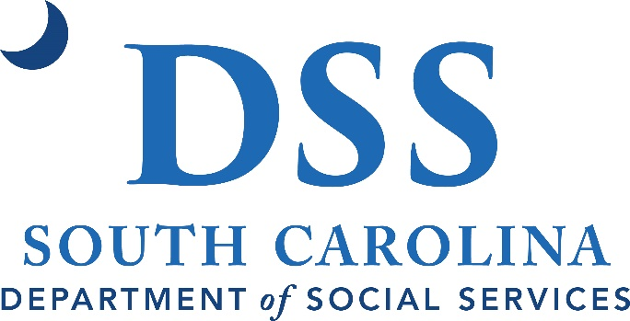

South Carolina Department of Social Services

Disaster Plan 2020 - 2024

DISASTER PLANNING
States have been asked to submit their procedures for how the State would respond to a disaster for programs funded under title IV-B, subparts 1 and 2. The following criteria are to be addressed by States:
- identify, locate and continue availability of services for children under State care or supervision who are displaced or adversely affected by a disaster; respond to new child welfare cases in areas adversely affected by a disaster, and provide services in those cases;
- remain in communication with caseworkers and other essential child welfare personnel who are displaced because of a disaster; preserve essential program records; and
- coordinate services and share information with other States (Section 422(b) (16) of the Act).

Identify, locate and continue availability of services for children under State care or supervision who are displaced or adversely affected by a disaster; and respond to new child welfare cases in areas adversely affected by a disaster, and provide services in those cases:

- All foster homes, per regulations and policy, must have written disaster plans in place prior to licensure and these plans are monitored for updates during quarterly visits by licensing staff. The plans must identify where the family plans to relocate during an evacuation or if there is a need for them to leave their residence. A Disaster Plan template (DSS Form 30246) for foster homes was finalized and given to county staff and child placing agency staff.

- All foster care homes have been given disaster brochures (DSS form 30199) with pertinent information and the emergency hotline number and are required to contact this number to report their location upon evacuation.

- Staff are required to locate alternative placement for any foster child in the event an evacuation order has been issued and a foster family is refusing to evacuate.

- Staff are required to follow up with foster families and to further assure their safety in their residences or new locations.

- All group homes and child caring institutions in the state are required per regulations and policy to have disaster plans in place. These are monitored by state level licensing staff at SCDSS. Copies of disaster plans for all group homes and all child placing agency foster homes have been submitted to state licensing staff at SCDSS and are on file.

- State level SCDSS foster home, group home, and child placing agency licensing staff are required to be on call to assist in communication and relocation efforts for any displaced children. These same staff will follow up after a disaster to assure safety for children in group home facilities. State level SCDSS Licensing and Disaster Response staff along with group home managers and child placing agency managers and the SC Emergency Management Division have working draft of an - All Hazards Disaster Emergency Operations Plan Development and Procedures Guide as relates to children in foster and group care.
- Child welfare (and other programs) staff statewide were required to be certified with specific online training courses and must keep their personal contact information updated in the event of an emergency. Staff is also certified with this coursework so they may assist in shelter operations when called upon.
- In order to respond to new child welfare cases in areas adversely affected by a disaster, all reports of an emergency nature received during a time of disaster will be coordinated through local law enforcement to assist CPS to respond. State statute provides that reports of suspected child abuse and neglect can be made to law enforcement as well as to the Department of Social Services. Local law enforcement routinely provides coverage for after normal business hours emergency reports and this system is established in all counties. Reports of concern for a child‘s

safety will be made to the local law enforcement emergency number. Child Protective Services offices will continue to have on-call staff that will be available to assist if the need arises.
Situations reported during a disaster can be anticipated to be of an emergency nature as everyone in the community likely will be affected by the disaster. Law Enforcement and other emergency services personnel may be the only people who are allowed to be at their place of work and law enforcement will be needed to make the necessary response to imminent danger, such as emergency protective custody action. If a child must come into care, this process segues into the foster care system as described above.
Ongoing services to a family in an active in-home treatment case will be triaged during the disaster period so that only emergency services will be provided, other situations will be responded to as soon as the immediate crisis is reduced. It is anticipated that few other routine services will be available during the time of disaster so the focus must be on responding to emergencies. The Human Services Manual, Chapter 7 – Child Protective and Preventive Services has been updated.

CHAPTER 7, Child Protective and Preventive Services
Revision Number: 10-01 Effective Date: 01/14/2010

739 CPS Investigations and Ongoing Services in Event of Natural or Man-Made Disaster
Purpose: To outline procedures to guide the response to new child protective services reports in areas adversely affected by a man-made or natural disaster, as well as for providing ongoing services as necessary. In the event of a disaster where communication and transportation systems are disrupted or an evacuation is ordered, routine services may be suspended and only emergency services available. In the event of a mandatory evacuation order due to a disaster, such as a hurricane or act of terrorism, the employees of the department will follow directions as given by the agency in authority and prescribed by the DSS Disaster Plan. Nothing in this section should be seen as supplanting the agency disaster plan.

Social Services Worker/Supervisor New Reports
- Ensures that all reports of an emergency nature received during a time of disaster are coordinated through local law enforcement to assist CPS to respond. State statute provides that reports of suspected child abuse and neglect can be made to law enforcement as well as to the Department of Social Services. Local law enforcement routinely provides coverage for after normal business hours emergency reports and this system is established in all counties. Reports of concern for a child’s safety will be made to the local law enforcement emergency number. Child Protective Services offices will continue to have on-call staff that will be available to assist if the need arises.

Situations reported during a disaster can be anticipated to be of an emergency nature as everyone in the community will be affected by the disaster. Law Enforcement and other emergency services personnel may be the only people who are allowed to be at their place of work and law enforcement will likely be needed to make the necessary response to imminent danger, such as emergency protective custody action. If a child must come into care, this process segues into the foster care system as described in Chapter 8.

On-going Treatment Cases
- Ensures that ongoing services to a family in an active in-home treatment case are triaged during the disaster period so that emergency services are provided, with other situations responded to as soon as the immediate crisis is reduced. It is anticipated that few other routine services will be available during the time of disaster so the focus must be on responding to emergencies.

Remain in communication with caseworkers and other essential child welfare personnel who are displaced because of a disaster; and preserve essential program records:

SCDSS has a disaster response plan in place as relates to telephone service and computer system access. The agency‘s data network allows for agency staff to access program systems and information from locations outside of

their own specific counties – should county staff need to relocate into other county offices. In this way, the majority of client information already on file, and the eligibility processes needed to process new referrals, can still be accessed after a disaster.
The Child Welfare program uses an automated case file that is supplemented by a paper file. Currently, in the case of a disaster, the paper file would continue to be at risk. The agency is currently in the planning process to begin having the ability to image the contents of the paper files so that they will be linked to the automated system. This should provide greater access from any location and also will assure that information is not lost due to disaster such as fire, flood, etc.

Coordinate services and share information with other States (Section 422(b) (16) of the Act):

The South Carolina Department of Social Services (SCDSS) has trained over 1500 staff through independent study coursework from the Emergency Management Institute (and in conjunction with FEMA guidelines).
For reference, the following procedures are taken directly from current policy manuals and have been updated. Following the policy information is more detail about agency and state disaster plans.
South Carolina Department of Social Services

CHAPTER 8, Foster Care
Revision Number: 09-04 Effective Date: 05/14/2009

839 Evacuation of Foster Children in the Event of a Disaster
In the event of a mandatory evacuation order due to a disaster (e.g., hurricane), foster children are to be evacuated to a designated shelter or a safe location that is not threatened by the disaster. Foster care or adoptions staff may be
asked to assist as needed. The State Office licensing staff will assist group care providers and child placing agencies
(therapeutic foster care providers licensed by private providers) with making arrangements for housing with other
providers. This serves to provide information and guidance for foster care staff to obtain the whereabouts and
location of foster children.

Foster Care Worker
1. Informs foster parents to contact the DSS Disaster Hotline (1-800-700-1156) if evacuating or leaving their home. Foster Parents need to be prepared to forward the following information:
a. child’s name;
b. county or office of case management;
c. current whereabouts; and
d. a phone number where they can be reached.
2. Makes alternative placement arrangements for foster child, if foster parent chooses not to comply with a
mandatory evacuation order.
3. Informs the foster parent in the event that the foster parent plans to evacuate to a residence rather than a
designated shelter, foster parent must be certain that:
a. the location is safe and is large enough to accommodate everyone; and
b. the location of the residence is located far enough away to not be threatened by the disaster; and
c. the name, address and telephone number of the residence is shared; and
d. the residence is appropriate for the needs of the child.
4. Instructs foster parent to contact the county or office of case management with the following information as soon
as lines of communication are restored:
a. the safety and condition of the foster child and family; and
b. the current living arrangements; and
c. the condition of the home (if known); and
d. whether or not the foster family can reside in the home (if known).
5. Contacts State Office Foster Care Licensing Staff, as needed, for additional information related to plans for group
care providers and foster parents licensed by private providers.

CHAPTER 9, Foster Care Licensing
Revision Number: 04-01 Effective Date: 02/23/2004
916 Disaster Preparedness Plans for Foster Families
In the event of a disaster such as a hurricane, foster parents need to be prepared to act quickly and decisively. While
it is impossible to be ready for every conceivable disaster, a plan is the first step to ensuring that foster parents and
children are safe. As a prerequisite to licensure, all foster parents are required to have a plan in place initially and
annual reviews thereafter. This section serves to provide guidance to issues surrounding disaster preparedness for
foster parents and staff. Please note that "listings of shelters" are not always available as many shelters are identified
only at the time of emergency/need.

Licensing Worker
1. Reviews the foster parents’ written evacuation plans during the initial assessment and at the time of re-licensing
(or if there is a change of residence). The plan should include the following topics:
a. Disaster preparedness plans that are responsive, flexible, appropriate to the situation and
include several locations to choose from.
b. If the child is considered medically fragile, specifics pertaining to the child’s needs, conditions,
medications and supplies are required in writing. In addition, the plan should reflect attendance at
a regular shelter, a Special Medical Needs Shelter (accompanied by a caregiver), another facility or
a home that can accommodate the child’s special needs. (Refer to the county emergency plan for
a listing of shelters to accommodate the medically fragile - if a listing is available).
c. Foster children must be evacuated when there is a mandatory evacuation order.
d. Foster parents should evacuate to shelters that have been approved by the local emergency/disaster preparedness plan.
e. In the event that the foster parents plan to evacuate to a residence, they must be certain that:
- the location is safe and is large enough to accommodate everyone; and
- the location of residence is located far enough away to not be threatened by the disaster; and
- the name, address and telephone number of the residence is available; and
- the residence is appropriate to the needs of the child.
2. Reviews and discusses with foster parents approved shelters in the local area on an annual basis, (if a listing is
available).
3. Informs the foster parents to contact the DSS Disaster Hotline at (1-800-700-1156) at the time of evacuation with the following information:
a. foster child’s name; and
b. county or office of case management; and
c. foster child’s whereabouts and situation; and
d. the telephone numbers where the child/family can be reached.
4. Instructs foster parents to ensure that the foster child’s name is listed on an attendance roster, if they are
evacuating to a shelter.
5. Informs foster parents to contact the local county or office of case management as soon as lines of communication
are restored with the following information:
a. the safety and condition of the foster child and foster family; and
b. the current living arrangements; and
c. the condition of the home (if known); and
d. whether or not if they can reside in the home (if known).
6. Amends the foster home’s license if the home has been damaged and is not habitable.
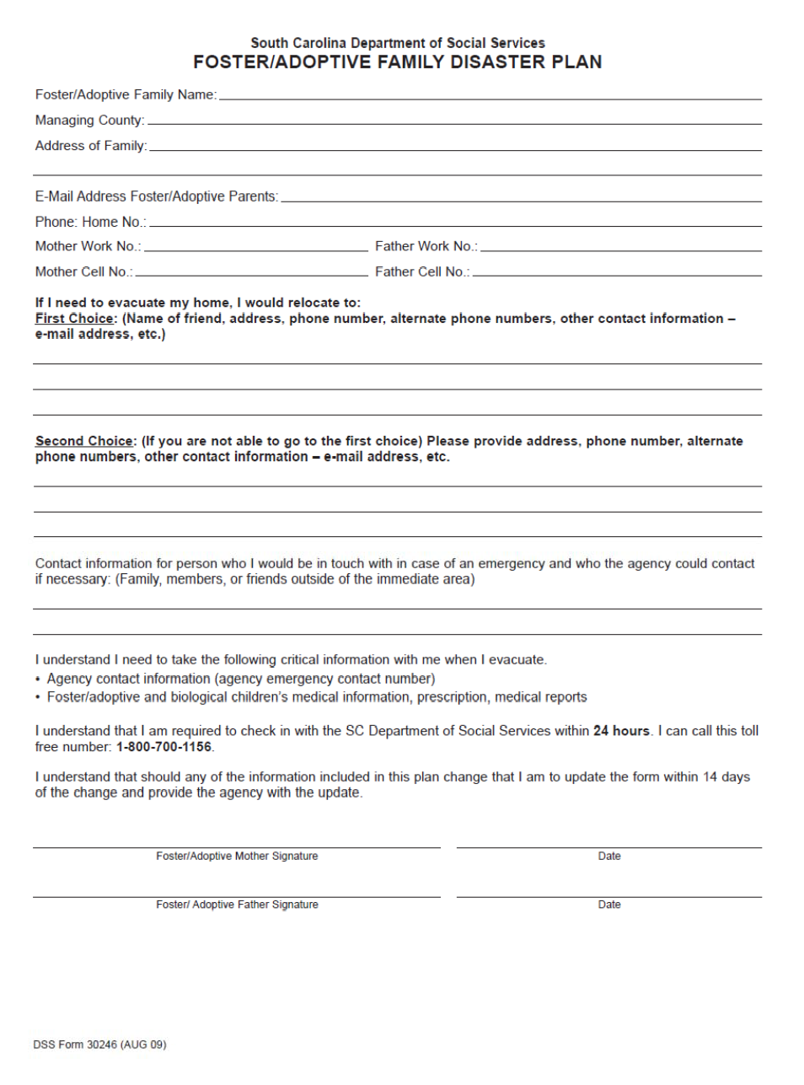

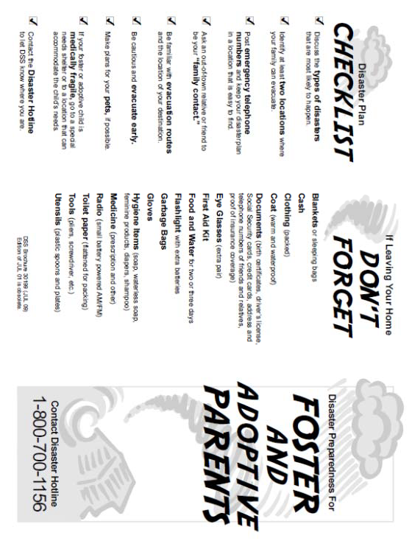

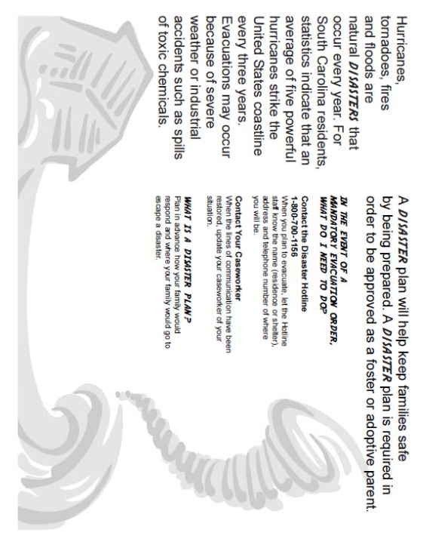

CUSTOMER INTERFACE Introduction
State customer agencies were tasked with establishing a comprehensive disaster recovery program by July 1, 2001. Recovery of critical information systems is expected to be a key component of the individual customer agency recovery plans. The SC Department of Administration/Division of Technology Operations (DTO) will work with customer agencies to interface agency plans to the DTO plan but cannot address customer agency disaster recovery needs beyond the scope of the DTO Disaster Recovery Plan.

Customer Agency Disaster Recovery Contacts
DTO will interface with each customer agency through its assigned disaster recovery contact. This will include training and consultation on data backup and off-site tape storage practices, as well as coordination of disaster recovery testing exercises. In the event of a disaster declaration, DTO will work with the disaster recovery contact for each customer agency to expedite recovery activities. An alternate for the contact is required.
Refer to the section entitled Telephone Directory, section VII, for a list of customer agency disaster recovery contacts.

Emergency Communications
In the event of an emergency affecting DTO production services, DTO disaster recovery team members will alert the appointed customer agency disaster recovery contact. Status updates and recovery activity coordination will also be via the customer agency disaster recovery contact. In order to assure that contact can be made under a variety of unpredictable circumstances, DTO recommends that the customer agency identify a Primary contact and at least one alternate. These personnel should provide all of the following:
  - Office telephone that is always answered during normal business hours and not subject to power outages
(i.e., Centrex telephone service, not electronic key or PBX without power back up).
  - Job title
  - E-mail address

DTO has provided a list of current customer agency disaster recovery contacts; refer to section entitled Telephone Directory that has been provided by our customer agencies. This list should be reviewed to ensure that the appropriate agency contact is listed. If there are any updates to this list, please contact Paul Creede, DTO Business Continuity Coordinator, at (803) 896-0680.
It is the responsibility of the customer agency disaster recovery contact to establish an internal notification process within the customer agency. DTO will call only one designated agency disaster recovery contact.

Executive Summary

  - SC Department of Administration / Division of Technology Operations (DTO) State Data Center
The Department of Social Services has entered into an agreement with The SC Department of Administration / Division of Technology Operations (DTO) for Disaster Recovery Services for the Server and Infrastructure hosting processing services the Department of Social Services currently utilizes.
The Division of Technology Operations (DTO) owns and operates the State Data center that supports data processing services for a number of South Carolina public agencies including the Department of Social Services.

DTO is the custodian of these applications and their associated data assets, while DSS is the owner and ultimate beneficiary of the automated functions. DTO is responsible for the physical environment and equipment assets. It employs generally accepted systems management practices in its daily operation and in its contingency planning.
A partnership between DTO and DSS is necessary to protect the applications and information assets within the data center. This partnership must extend to the design, implementation, validation and ongoing maintenance of a recovery capability.
In the event of a disaster that would render the computer center unable to provide normal production computing services, DTO has a goal to restore service in a timely manner. Toward that end, DTO has established a Disaster Recovery Program. This program exists to benefit DTO customer agencies and to encourage joint participation between DTO disaster recovery teams and key disaster recovery personnel within the agencies/departments that use DTO computing services.

Appendix A contains the Customer Guide to the DTO State Data Center Disaster Recovery Program and describes the roles and responsibilities for DTO and DSS.

Department of Social Services Division of Technology Services
The DSS Division of Technology Services provides network access and PC support to approximately 5000 end users located at 80 locations throughout the state of South Carolina. This responsibility includes the Hardware and Software components of the Physical Networking, Wan Protocols, LAN Protocols, LAN Operating Systems and PC Operating Systems.
In the event of total loss of network operation at the State DSS Office located at 1535 Confederate Avenue the following action plan would be implemented:

By utilizing the state contract for pre-approved vendors DSS would replicate the SAN and county server configuration and host it at the DTO State Data Center located at 4430 Broad River Road. All necessary line and communication components would be redirected to the DTO State Data Center. LAN backups would be loaded on the new equipment. After the infrastructure is tested and the connection is verified it will be made available for real time production work to the various DSS locations.

Appendix B contains the South Carolina Department of Social Services Information Technology Summary describing the Hardware and Software for which DSS is currently responsible.

Appendix C contains the Department of Social Services Disaster Recovery Contact List for the State Office.

Appendix D contains the Department of Social Services Disaster Recovery Contact List and Locations for the County Offices.

DSS County Office Information Services
In the event of total loss of a DSS county office the following action plan would be implemented:
By utilizing the state contract for pre-approved vendors DSS would replace needed county hardware and software Employees would be redirected to other DSS offices for system access until needed county hardware and software was replaced and operational. By using Windows and Microsoft email an employee could access their desktop from any DSS agency computer.
3.1.15 CAPSS (Child and Adult Protective Services System)
Enterprise Management system of record for the Agency Child Welfare and Adult Advocacy case load. Modules include (Intake, Case Management, Provider Management, Licensing -Foster Homes, Adoptions), Dictation/Case Documentation, Financials (Board and AS Payments), Reporting (Internal, Federal - AFCARS, NCANDS, NYTD, NAMERS), Imaging, Interfaces.

CAPSS was implemented in October 2001 and currently supports approximately 1,500 users statewide.
CAPSS resides on the users ‘desktop and is also available via remote access via VPN. CAPSS is build on a .NET/SQL platform.

LCMS (Legal Case Management System).
Case Management system used by the Agency's attorneys and paralegals to manage Legal orders, Hearings, Outcomes. Interfaces with CAPSS. System is hosted @ DSS but software was developed by Spartan Technologies, they also hold the maintenance contract.

Appendix C
DSS State Office Disaster Recovery Contacts Primary Contact: Jose Encarnacion
Title: IT Director
Office Phone: 803-724-5325 Cell Phone: 803-237-9329
Email:Jose.Encarnacion@dss.sc.gov

Other Contact: Virginia “Kaye” Barnes
Title: Network Operations and Data Center Services Director
Work Cell Phone: 803-603-1515
Email: Kaye.Barnes@dss.sc.gov

Other Contact: Paulette Salley
Title: Human Services Applications Manager (Child Welfare, Adult Advocacy)
Office Phone: 803-724-5931 Cell Phone: 803-603-3522
Email: Paulette.Salley@dss.sc.gov

Other Contact: Josh Emory
Title: Admin Systems Applications Manger
Office Phone: 803-724-5244
Cell Phone: 803-727-0237
Email: Josh.Emory@dss.sc.gov

